Comparing two figures

A disagreement seems to arise when comparing these two figures. The left shows the most functional sequences have 5+ aromatic and acidic and that a balance between these two moieties is needed. The figure on the right shows that the most functional balance is having 5 more acidics than aromatics. That over preference for acidics is not apparent in the figure on the left. How can we explain the apperance of these two figures.

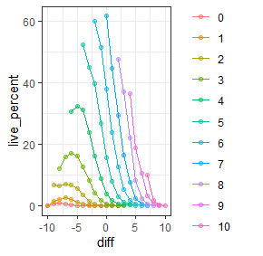 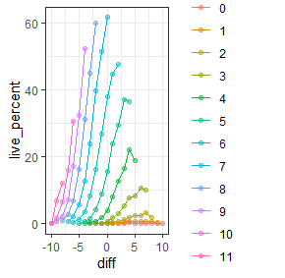

These graphs are like the figure on the right at the top of this page, except they are split by aromatic count (left) or acidic count (right). We can see the highest live% is when the balance is 0, with 7 aromatic and 7 acidic. These graphs were filtered so each point displayed here had at least 100 non-functional sequences.

I interpret this data as the sequence needs a good acidic profile to function. That is why the figure at the top right is shifted towards acidic balance. Only a few aromatics are needed once an acidic background has been set. Now the best option is balanced acidic and aromatic, but a sequence will still function with a lower amount of acidic compared to aromatic.

Another way to think about this is it’s possible to be too aromatic. Where as its harder to be too acidic. Too many aromatics will not allow the sequence to properly spread out. Too many acidics just spreads the sequnce out even more. As long as a few aromatics are present these extra spread sequences will function fine.

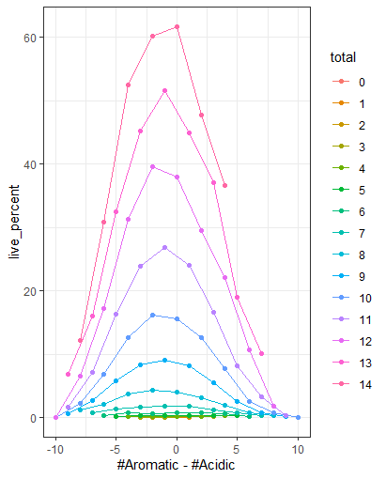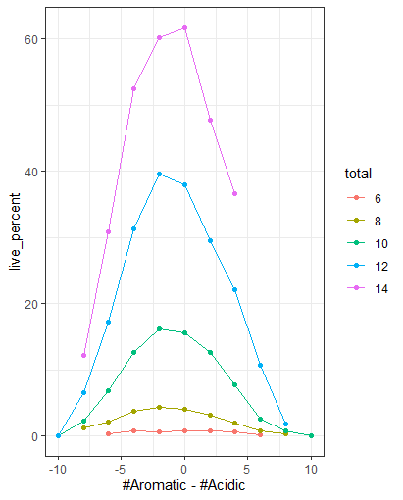

Filtered for die count at least 100.. I chose 5 lines to show over all trends.

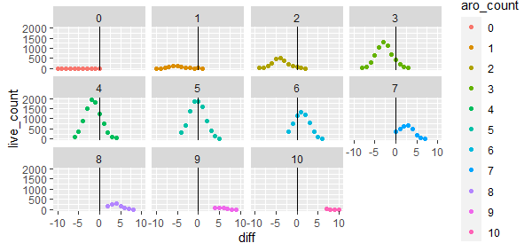

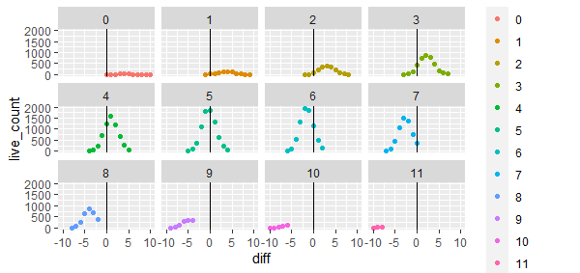

The data is very consistent when looking at holding diff the same

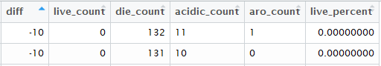



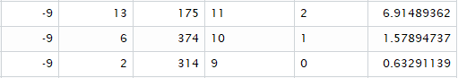

Better to have 10-1 than 1-10



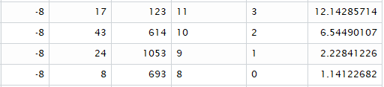

Better to have 10-2 than 2-10

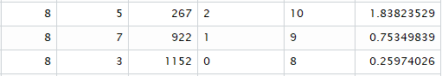

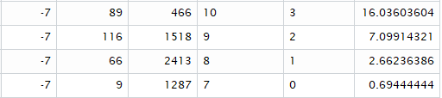

Better to have 10-3 than 3-10,

Better to have 9-2 than 2-9

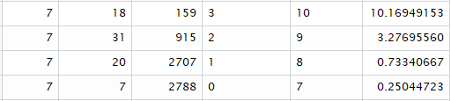

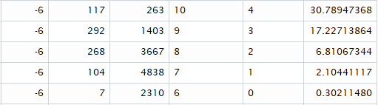

Better to have 9-3, 8-2, 7-1

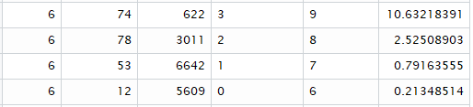

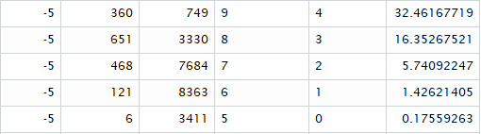

Better to have 9-4, 8-3, 7-2, 6-1

